Communicating with Dr. Gardenghi
MS Teams is my preferred method of communication with students (I am less likely to miss/lose your chat message than an email, and chat is more efficient and interactive than waiting for emails to show up in the system).

Scheduling an Office Hour Appointment with Dr. Gardenghi
Office hours will be by appointment since this has worked well in the past. This is to reduce “lines” outside the office. Appointments are available in 20-minute slots in person or online, so you will want to come with your questions ready and organized. If another student has an appointment immediately following yours, your appointment will need to end promptly. If you have a quick question, feel free to just send a chat in MS Teams.
Click the calendar link (https://calendly.com/mgardeng/20min). You will come to the following page. Find the date for which you wish to make the appointment.
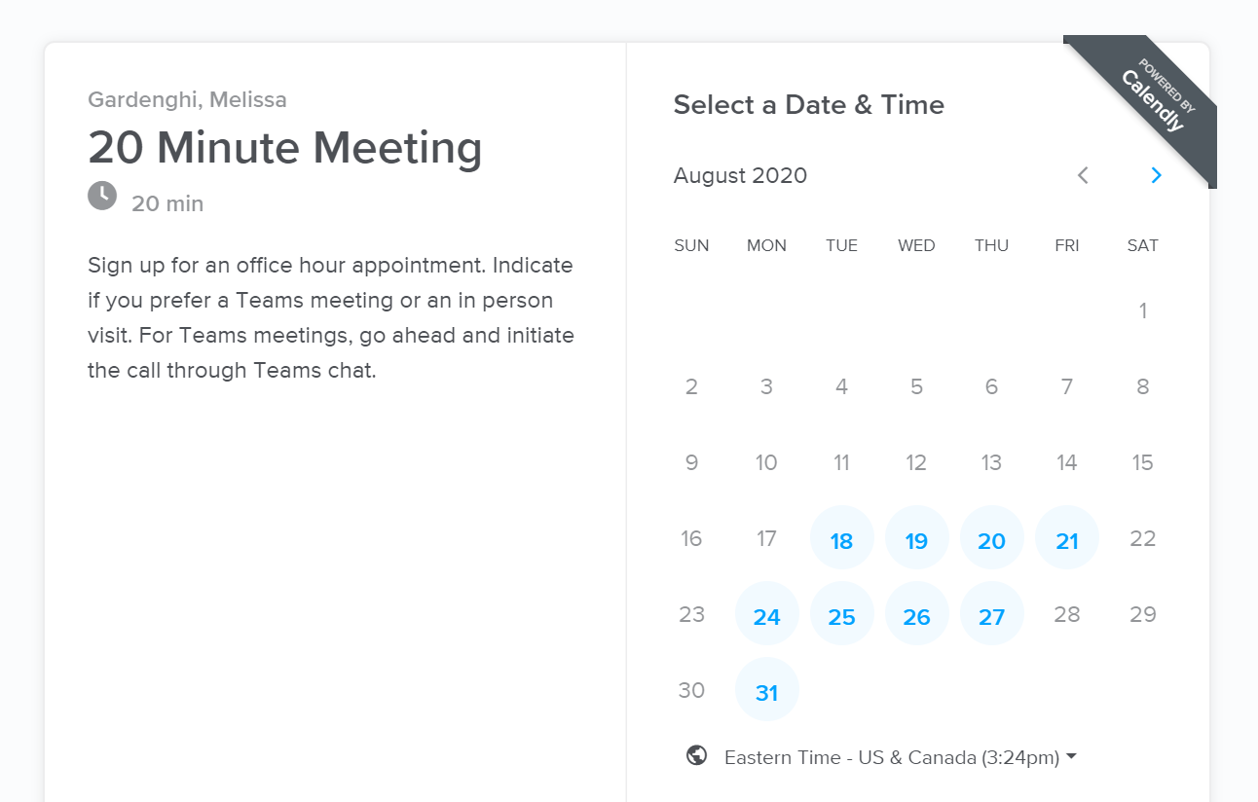

Select the time and click the Confirm button. Only dates/times with available time slots will be shown.
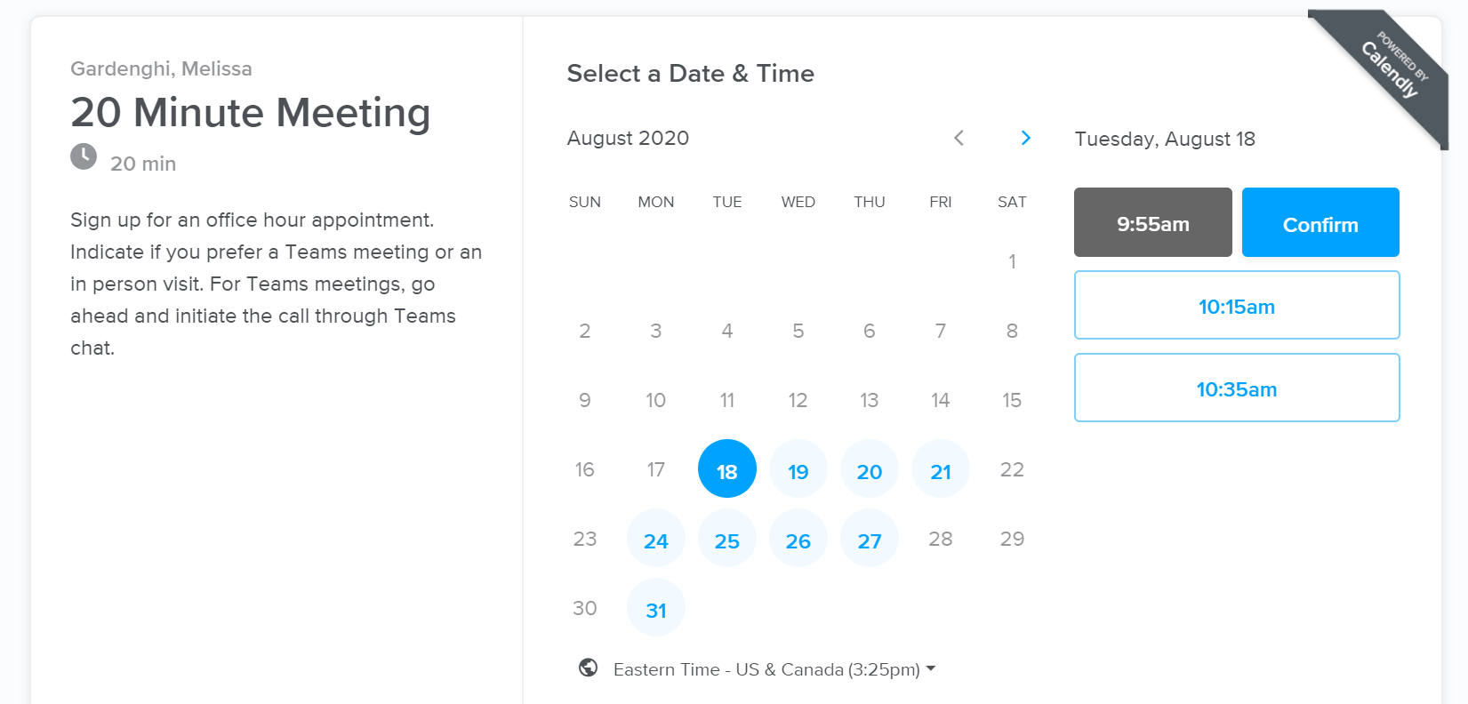

- Enter your name.
- Enter your email address (you can make “group” appointments by adding other emails).
- Click Schedule Event – you will then see a confirmation notice and your appointment will show up on my calendar (there is no need to confirm this with me).
- You should also receive an email appointment to accept and add the appointment to your own calendar.
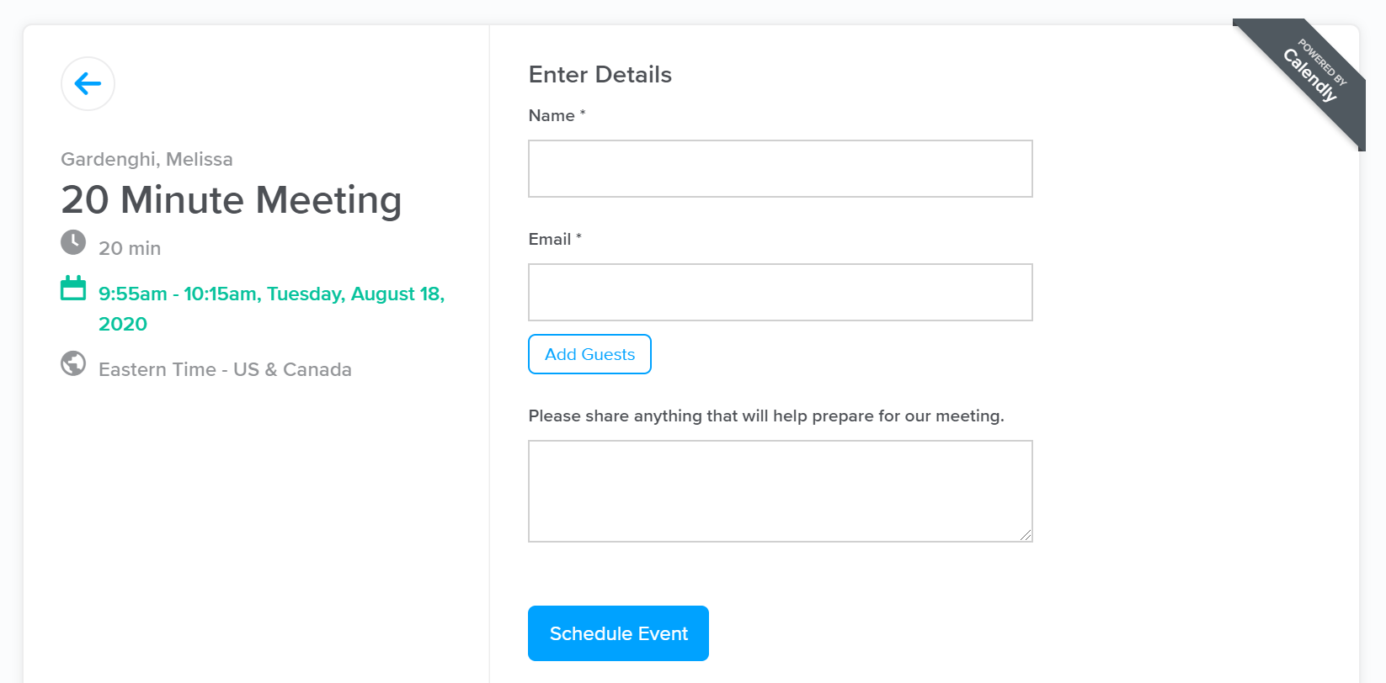

Then just come by my office at the appointed time (and if there’s still someone in my office, just sit/stand within view and I’ll be with you shortly).

