Communicating with Dr. Gardenghi
MS Teams is my preferred method of communication with students (I am less likely to miss/lose your chat message than an email, and chat is more efficient and interactive than waiting for emails to show up in the system).

Scheduling an Office Hour Appointment with Dr. Gardenghi
In an effort to support the physical distancing goals for this semester, office hours will be by appointment. This is to reduce “lines” outside the office. Appointments are available in 20-minute slots in person or online, so you will want to come with your questions ready and organized. If another student has an appointment immediately following yours, your appointment will need to end promptly. If you have a quick question, feel free to just send a chat in MS Teams.
Click the calendar link (https://calendly.com/mgardeng/20min). You will come to the following page. Find the date for which you wish to make the appointment.
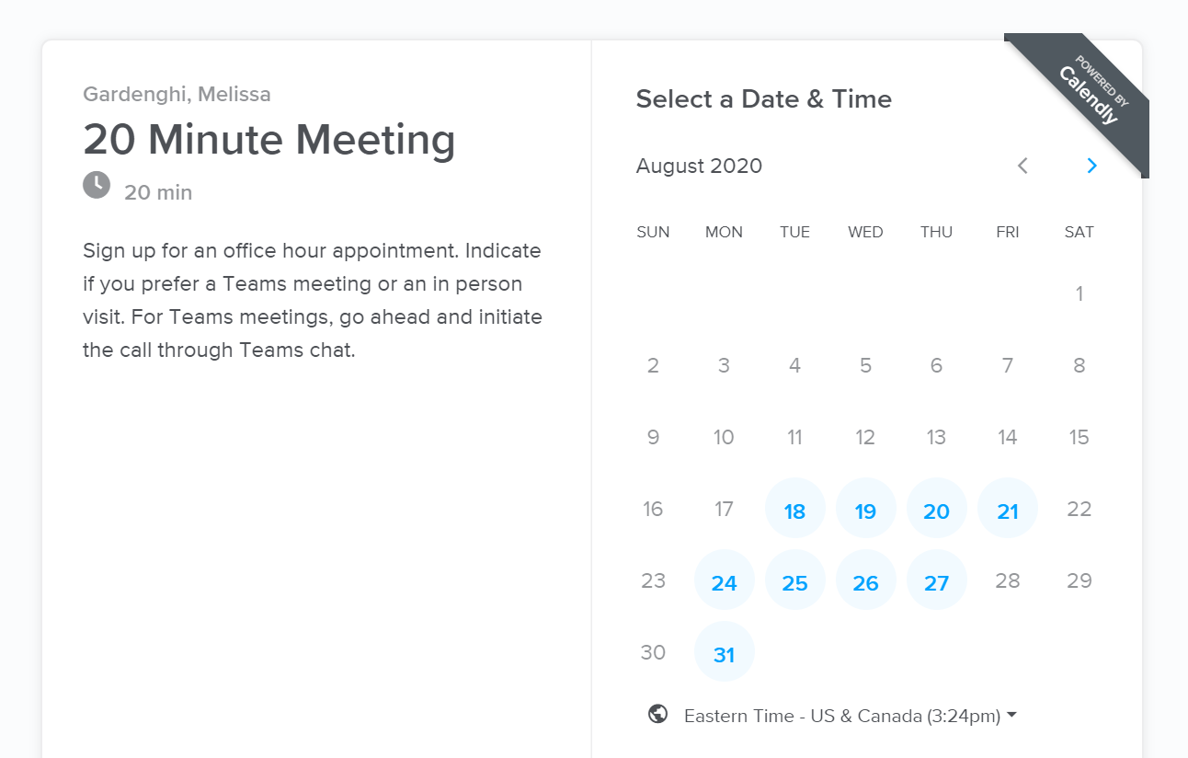

Select the time and click the Confirm button. Only dates/times with available time slots will be shown.
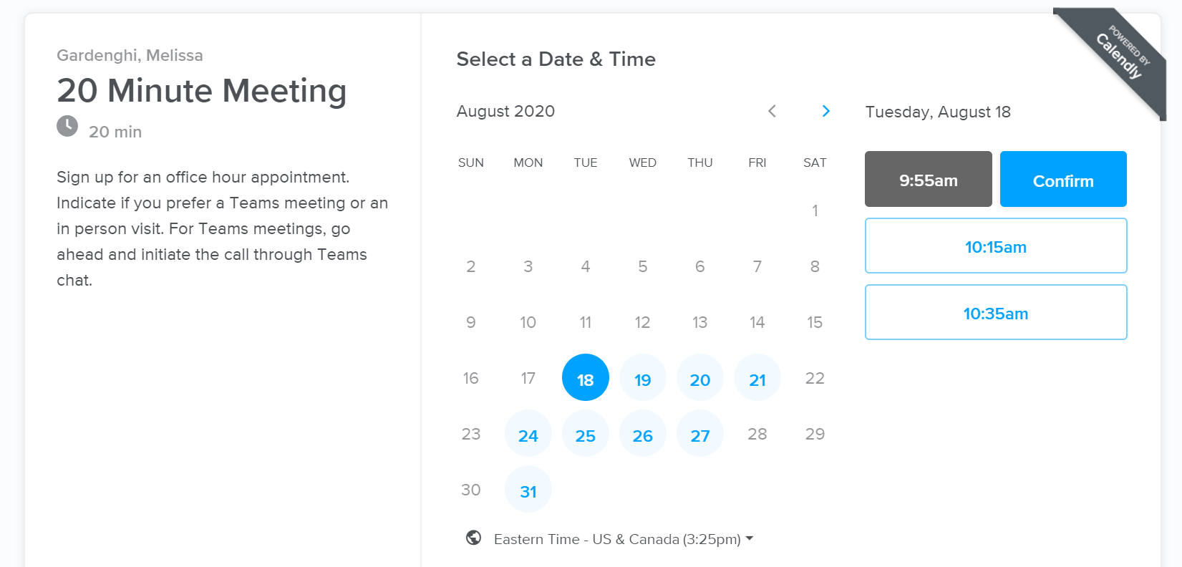

- Enter your name.
- Enter your email address (you can make “group” appointments by adding other emails).
- Indicate in the comments box the topic of the meeting (questions from class, questions on your project, advising questions, etc.)
- Also in the comments box indicate if you will be coming in person to my office, or if we will be chatting in MS Teams.
- Click Schedule Event – you will then see a confirmation notice and your appointment will show up on my calendar (there is no need to confirm this with me).
- You should also receive an email appointment to accept and add the appointment to your own calendar.
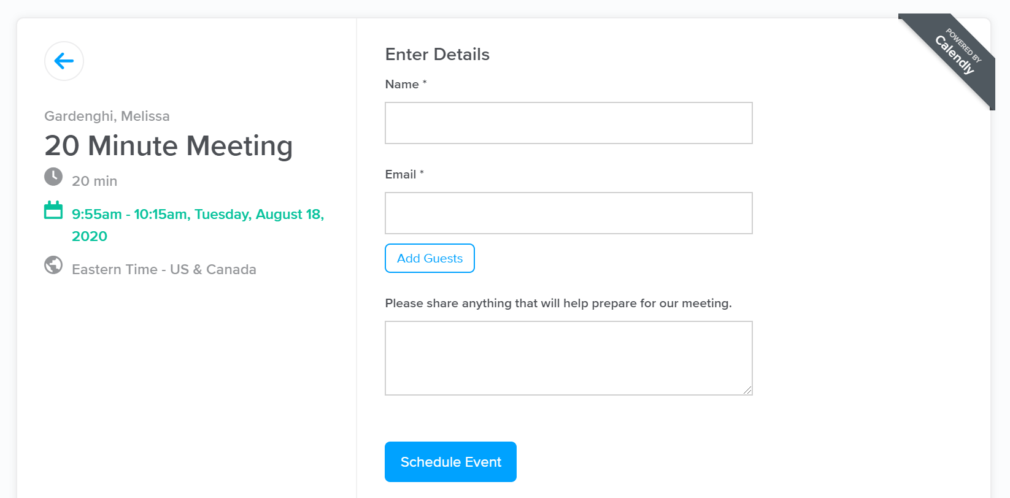

If you are planning on coming by my office, then just come by at the appointed time (try not to loiter/congregate too much in the hallway in accordance with our physical distancing goals).

If you are planning on conversing by MS Teams, then go ahead and initiate a video call through the MS Teams Chat when your appointment time arrives (I will be waiting to hear from you).
- Search for Melissa Gardenghi in the Chat option in MS Teams … make sure not to get the other Gardenghis that are on campus.
- Add any other students who wish to join the call to the chat using the add button
in the top righthand corner.
- Initiate the video call by selecting the video button from the top righthand corner.

